

**SCHOOL OF PHYSICS**

# UNIVERSITI SAINS MALAYSIA

**ZCT191/192 PHYSICS PRACTICAL I/II**

1GP2 PROJECTILE MOTION

***Lab Manual***

# OBJECTIVES

1. *To determine the projectile range as a function of inclination angle;*
2. *To determine the maximum height of projection as a function of projection angle;*
3. *To estimate the value of the gravitational acceleration of the Earth; and*
4. *To determine the maximum projectile range as a function of initial speed.*

# THEORY

## Introduction

In this experiment, we will study the projectile motion of a steel ball using PHYWE’s Projectile Motion experiment set. A steel ball is fired by a spring at different velocities and at different angles to the horizontal. Using the data collected, we will investigate the relationship between the range, height of projection, angle of projection and initial speed of the projectile.

## Projectile Motion

**Figure 1:** Movement of a mass point under the effect of gravitational force.

If a body of mass 𝑚 moves in a constant gravitational field (gravitational force 𝑚𝑔⃗), the motion lies in a plane (**Figure 1**). If the coordinate system is laid in this 𝑥-𝑦 plane, the *equation of motion* 𝑟⃗(𝑡) is

|  |  |
| --- | --- |
| 𝑑2  𝑚 𝑑𝑡2 𝑟⃗(𝑡) = 𝑚𝑔⃗. | (1) |

If 𝑟⃗ = (𝑥, 𝑦) and 𝑔⃗ = (0, −𝑔) , and the initial position and velocity are 𝑟⃗(0) = (0,0) and

𝑣⃗(0) = (𝑣0 cos 𝜙 , 𝑣0 sin 𝜙), we obtain the *coordinates* as a function of time 𝑡,

|  |  |
| --- | --- |
| 𝑥(𝑡) = 𝑣0𝑡 cos 𝜙  1  𝑦(𝑡) = 𝑣0𝑡 sin 𝜙 − 𝑔𝑡2.  2 | (2) |

From this, the *maximum height* of projection ℎ is obtained as a function of the *angle of projection* 𝜙,

|  |  |
| --- | --- |
| 𝑣2  ℎ = 0 sin2 𝜙,  2𝑔 | (3) |

and the *maximum range* 𝑠 is

|  |  |
| --- | --- |
| 𝑣 2  𝑠 = 0 sin 2𝜙.  𝑔 | (4) |

**Figure 2** shows the maximum height as a function of projection angle, and we see that the higher the initial velocity, the higher the maximum height. On the other hand, the maximum range is reached at the projection angle of 45° for every initial velocity, as shown in **Figure 3**. By choosing a logarithmic scale, a regression line can be applied to the measured data and used to determine the maximum range for arbitrary initial velocities (**Figure 4**).

|  |  |
| --- | --- |
|  |  |
| **Figure 2:** Maximum height of projection ℎ as a  function of angle of projection 𝜙 at different initial velocities 𝑣0. | **Figure 3:** Maximum range 𝑠 as a function of angle of projection 𝜙 at different initial velocities 𝑣0. |

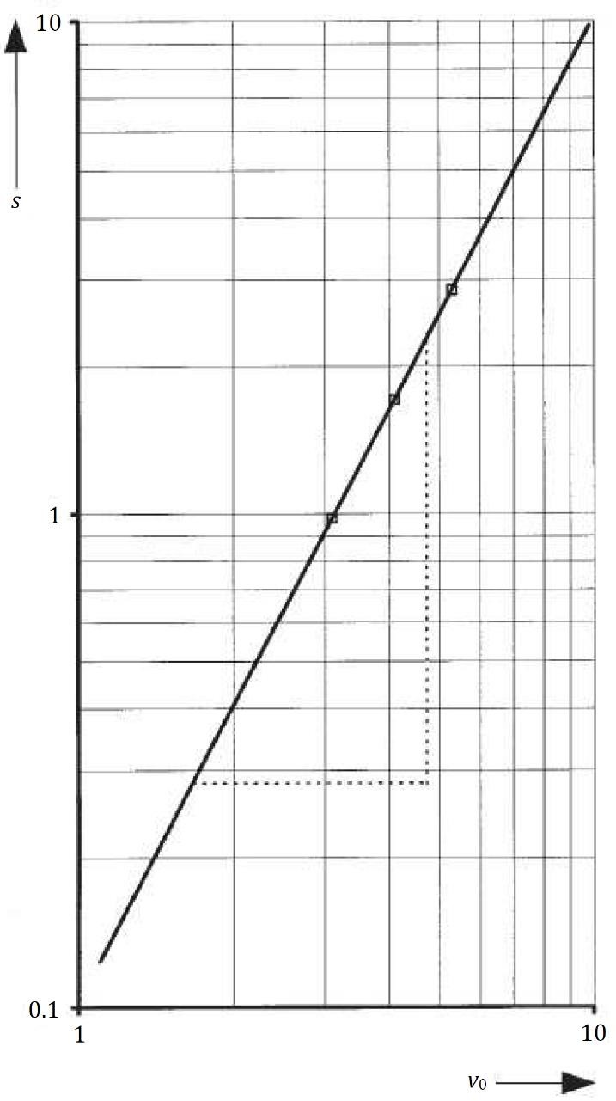

**Figure 4**: Maximum range 𝑠 as a function of initial speed 𝑣0 with a fixed angle of projection 𝜙 = 45°.

# EQUIPMENT

1. Ballistic unit
2. Recording paper (1 roll, 25 m)
3. Steel ball (𝑑 = 19 mm)
4. Two-tier platform support
5. Scale on rod (𝑙 = 750 mm)
6. Barrel base expert
7. Speed measuring attachment
8. Power supply (5 V DC/4 A)

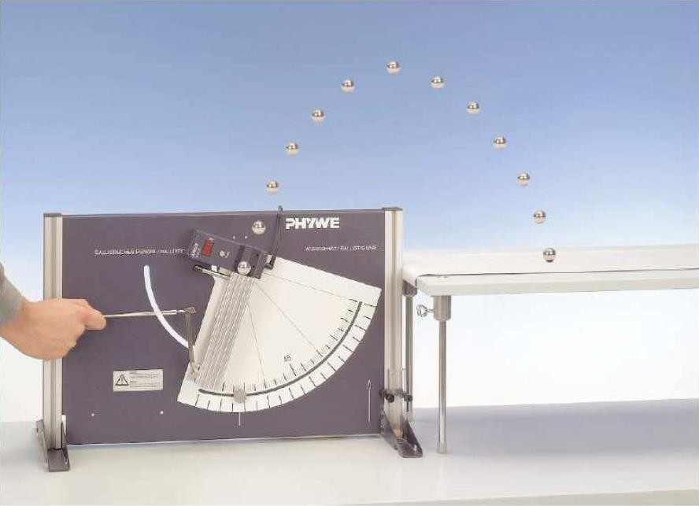

Steel ball

Speed measuring attachment

Recording paper

Two-tier platform

Ballistic unit

**Figure 5:** PHYWE’s Projectile Motion experiment setup.

**Figure 5** shows the experiment setup used in this study. The experiment setup consists of four main parts:

1. The *ballistic unit*, which launches the steel and wooden ball. It contains a spring with three adjustable tension stages, each corresponding to a different initial firing speed of the projectile.
2. The *speed measuring attachment*, which measures the initial speed of the projectile.
3. The *two-tier platform support* and *recording paper*, which are used to mark the location where the projectile lands so that the range can be determined.
4. The *scale* / *ruler* (not shown in **Figure 5**), which is placed vertically so that the maximum height of the projection can be measured.

# PROCEDURE

Two experiments will be carried out in this study: **Part A** in the first week and **Part B** in the second week.

# Part A: Gravitational Acceleration of the Earth

## Measurement

1. Prepare the setup as shown in **Figure 5**.

To mark the points of impact, secure the recording strip to the bench with adhesive tape. To measure the height of projection, clamp the meter scale in the barrel base and move it parallel to the plane of projection. The heights of projection can be determined ballistically quite well by eye. Also, an empty box can be placed behind the bench to catch the ball.

1. Place the steel ball on the striker in the ballistic unit and pull the firing spring to the first tension stage (which corresponds to the first initial speed, 𝑣0,1).
2. Measure the distance between the striker and the centre between the light barriers (𝑑) and record its value in **Table 1**.
3. Adjust the ballistic unit so that the angle of projection on the scale reads 𝜙 = 25°.
4. Fire the steel ball and record its range (𝑠) and height of projection (ℎ) in **Table 1**. Also record the initial firing speed of the steel ball as displayed on the speed measuring attachment (𝑣exp).
5. Repeat **Steps 4–5**, but with the angles of projection 𝜙 = 35°, 45°, 55° and 65°.
6. Repeat **Steps 2–6** but with the second and third tension stages (which correspond to the second and third initial velocities, 𝑣0,2 and 𝑣0,3, respectively).

## Analysis

1. Calculate the actual initial speeds (𝑣0) for their corresponding experimental values (𝑣exp).

𝑣0 is given by the equation

|  |  |
| --- | --- |
| 𝑣0 = √𝑣2 + 𝑔𝑑 sin 𝜙.  exp | (1) |

This is required as the experimental initial speeds do not take into account the time taken for the ball to cover the measuring distance. Depending on the angle of inclination, the ball already leaves the light barrier with a reduced speed.

1. Plot the graph of maximum range (𝑠) vs. angle of projection (𝜙) for each initial velocity.
2. Plot the graph of maximum height of projection (ℎ) vs. angle of projection (𝜙) for each initial velocity.
3. Using the data collected for 𝑠 vs. 𝜙 and ℎ vs. 𝜙, plot two additional linear graphs to obtain the value of gravitational acceleration (𝑔).

**Table 1**: Data for **Part A**.

|  |  |  |  |  |  |
| --- | --- | --- | --- | --- | --- |
| **Angle of Projection,**  𝝓 | **Range,**  𝒔 **(m)** | **Height of Projection,**  𝒉 **(m)** | **Experimental Initial Speed,**  𝒗𝐞𝐱𝐩 **(**𝐦 𝐬−𝟏**)** | | **Actual Initial Speed,**  𝒗𝟎 **(**𝐦 𝐬−𝟏**)** |
| First initial speed, 𝑣0,1 (m s−1) [Distance, 𝑑1 = | | | | m] |  |
| 25° |  |  |  | |  |
| 35° |  |  |  | |  |
| 45° |  |  |  | |  |
| 55° |  |  |  | |  |
| 65° |  |  |  | |  |
| Second initial speed, 𝑣0,2 (m s−1) [Distance, 𝑑2 = | | | | m] |  |
| 25° |  |  |  | |  |
| 35° |  |  |  | |  |
| 45° |  |  |  | |  |
| 55° |  |  |  | |  |
| 65° |  |  |  | |  |
| Third initial speed, 𝑣0,3 (m s−1) [Distance, 𝑑3 = | | | | m] |  |
| 25° |  |  |  | |  |
| 35° |  |  |  | |  |
| 45° |  |  |  | |  |
| 55° |  |  |  | |  |
| 65° |  |  |  | |  |

# Part B: Maximum Range vs. Initial Speed

## Measurement

1. Prepare the same setup as in **Part A**.
2. Place the steel ball on the striker in the ballistic unit and pull the firing spring to the first tension stage (which corresponds to the first initial speed, 𝑣0,1).
3. Measure the distance between the striker and the centre between the light barriers (𝑑) and record its value in **Table 2**.
4. Adjust the ballistic unit so that the angle of projection on the scale reads 𝜙 = 45°.
5. Fire the steel ball and measure its range (𝑠). Also record the initial firing speed of the steel ball as displayed on the speed measuring attachment.
6. Repeat **Steps 2–5** but with the second and third tension stages (which correspond to the second and third initial velocities, 𝑣0,2 and 𝑣0,3, respectively).

## Analysis

1. Calculate the actual initial speeds (𝑣0) for their corresponding experimental values (𝑣exp).
2. Plot the graph of maximum range (𝑠) vs. initial speed (𝑣0).

**Table 2**: Data for **Part B**.

|  |  |  |  |
| --- | --- | --- | --- |
| **Experimental Initial Speed,**  𝒗𝐞𝐱𝐩 **(**𝐦 𝐬−𝟏**)** | **Distance,**  𝒅 **(m)** | **Range,**  𝒔 **(m)** | **Actual Initial Speed,**  𝒗𝟎 **(**𝐦 𝐬−𝟏**)** |
|  |  |  |  |
|  |  |  |  |
|  |  |  |  |

# REFERENCES

1. PHYWE (2019). Student’s Sheet for *Projectile Motion (P2131100)*.
2. PhysChem EMU (2020). *EMU Physics Department: “Projectile Motion” Experiment.*

Retrieved 5 Aug 2021 from [youtube.com.](https://www.youtube.com/watch?v=zsOZWW1fb4c)

# ACKNOWLEDGEMENT

This lab manual was originally created by *Dr. Edmund Loh Wai Ming* in 2021. This manual was revised and standardised by *Dr. John Soo Yue Han* in 2021.

*Last updated*: 03 April 2022 (JSYH)